IT 3060 Final Project
For this project, you will demonstrate your ability to do the following tasks by creating your own database that contains at least 4 tables.
Create a Database | Create an E-R Diagram | Create Tables | Design and Create Views
Insert Data | Implement a Stored Procedure | Implement a Trigger | Set up Security for a Database

Instructions:
- Download this document and rename it to, IT3060FinalProject_[YourLastName].
- All your work will be submitted on this document along with .sql files of your work.
- Note: You can utilize an AI tool to help you generate database ideas, help you generate scripts for your database, etc. However, it is up to you to analyze the information you get from the AI tool to modify the code to meet your specifications. You must implement the code in your database and run your code successfully and be able to troubleshoot any issues.

Part 1 – Creating a Database
Database Definition and Requirements:
The purpose of this database is to manage an auto repair shop’s customers, their vehicles, and their service history. The database stores customer contact information, the vehicles they own, service orders created for each vehicle, and detailed service items (labor and parts) for each order.
Users of this system include front desk staff, mechanics, and shop management. The database must allow staff to:
• Look up customers and their vehicles
• View past and current service orders
• Track parts and labor entries
• Retrieve customer service history quickly
The design includes four tables: Customers, Vehicles, ServiceOrders, and ServiceItems, each joined with primary and foreign keys.

Database E-R Diagram:
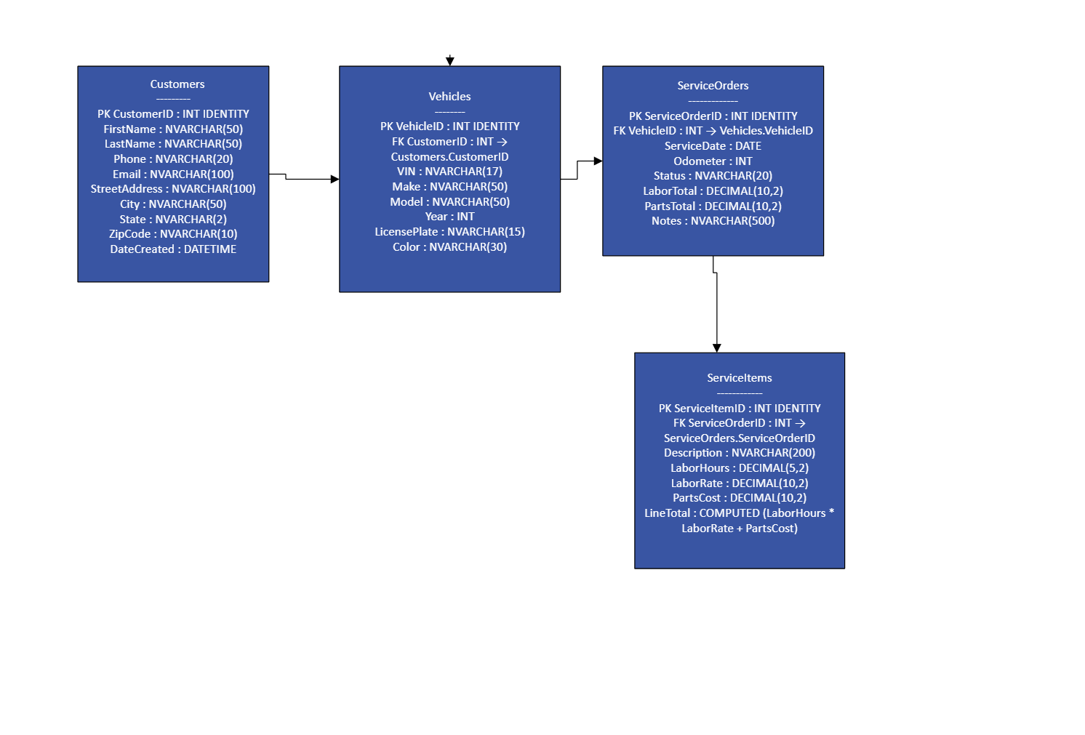Create Database and Tables:
Save your script to create your database and table script as, 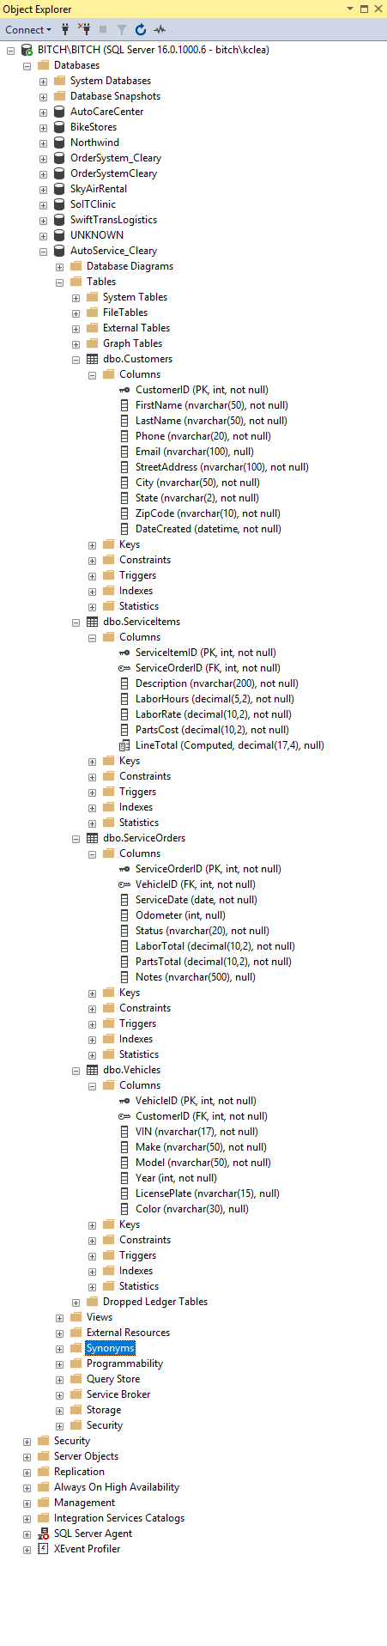IT3060FinalProjectCreateDBTables_[YourLastName].sql

Part 2 – Working with Data
- Create a script that will insert at least 5 – 10 records into each of your tables.
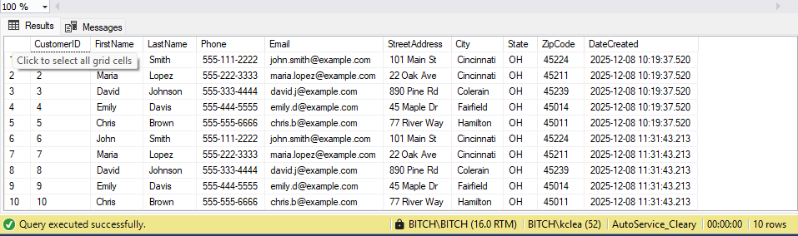
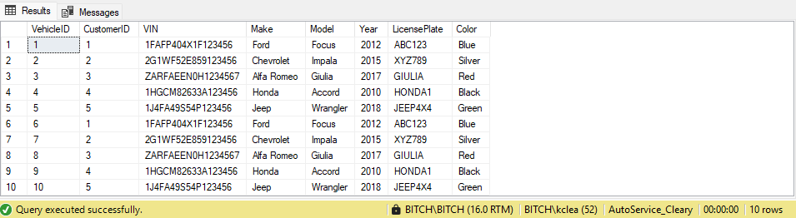
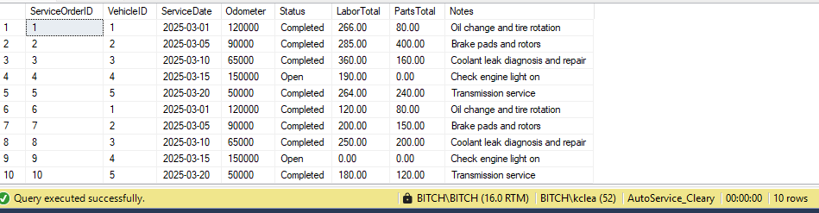
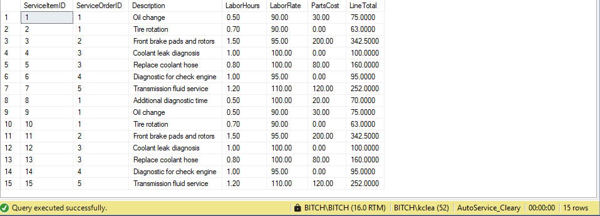
- Considering how a user would utilize your database, define 2 business processes that would require read-only access to the data. For these two examples, you will create a view that would support these requirements.
  - Business Process – Read Only #1
Front desk staff need to view recent service orders, including the customer’s name, vehicle details, service date, status, and total charges. This allows them to quickly answer customer questions and check the status of ongoing or recently completed service.
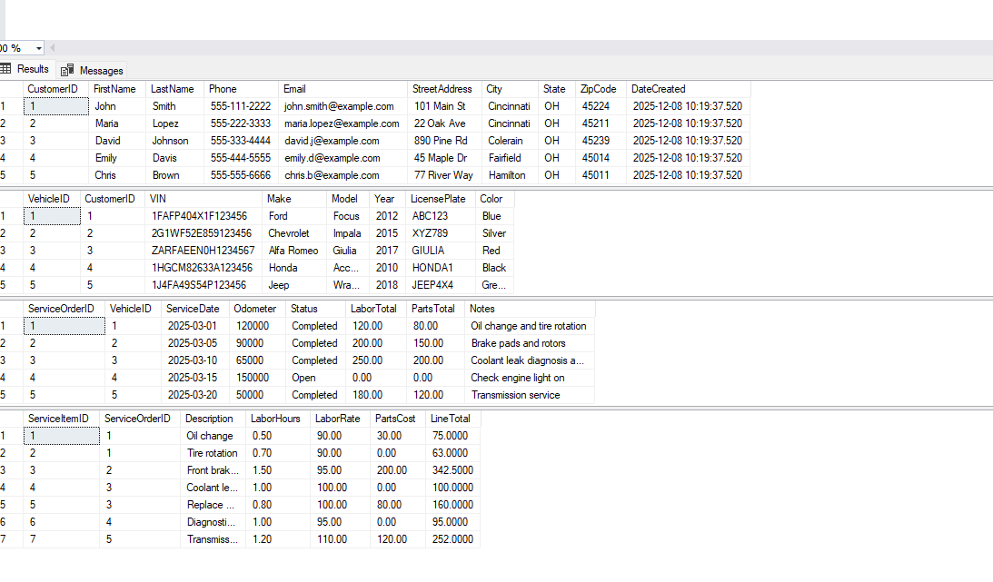
Create a view to support this business process. Save as IT3060FinalProjectCreateView1_[YourLastName].sql.

  - Business Process – Read Only #2
The shop owner needs to see how much total revenue each customer has generated. This includes how many service orders the customer has had and the total amount spent on labor and parts. This helps identify top customers and understand sales performance.
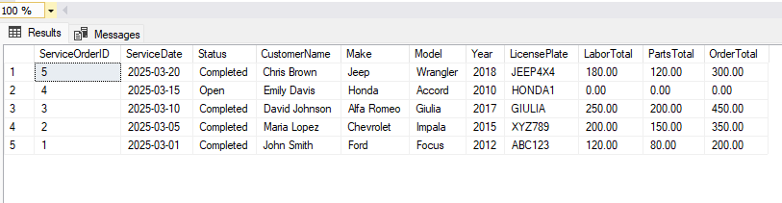Create a view to support this business process. Save as IT3060FinalProjectCreateView2_[YourLastName].sql.

Part 3 – Stored Procedures and Triggers
- Define a business process that would be needed by users to work with the data programmatically. The stored procedure should require at least one parameter, including at least one SQL statement, and a decision structure that will result in the output to the user.

Service advisors often need to look up service orders for a customer based on status (Open, Completed, or Cancelled). Instead of writing the full query each time, they should be able to run a stored procedure. The procedure accepts the customer’s last name and order status as parameters, validates the input using decision logic, and returns matching service orders with vehicle details.

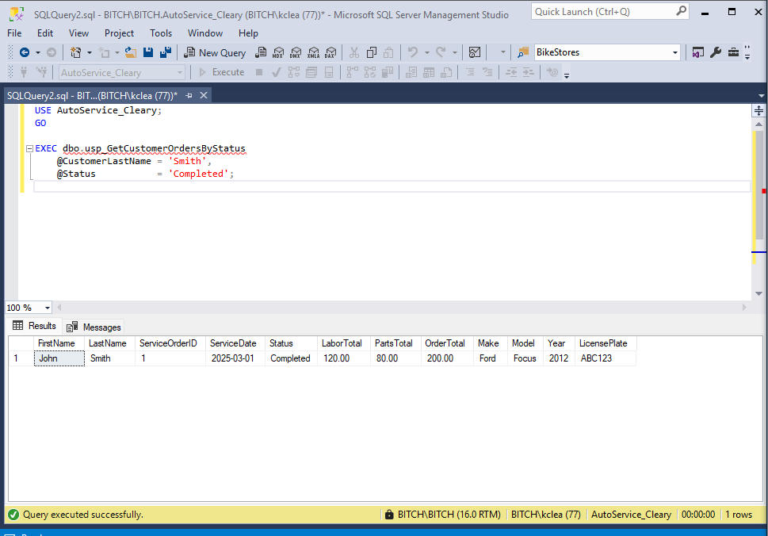
Create a view to support this business process. Save as IT3060FinalProjectStoredProcedure_[YourLastName].sql.

[Insert a screenshot of your EXEC statement running the Stored Procedure and displaying the results. Your server’s name in object explorer and database name should be included in the screenshot.]

- Define a scenario that would require a trigger to be created on at least one of your database objects. The trigger should contain a message that is output to confirm it runs. Create the trigger and demonstrate your test of this trigger executing with output.

When service items are added, updated, or deleted, the labor and parts totals in the ServiceOrders table must remain accurate. A trigger automatically recalculates totals whenever service items change. The trigger prints a confirmation message so users know it executed.

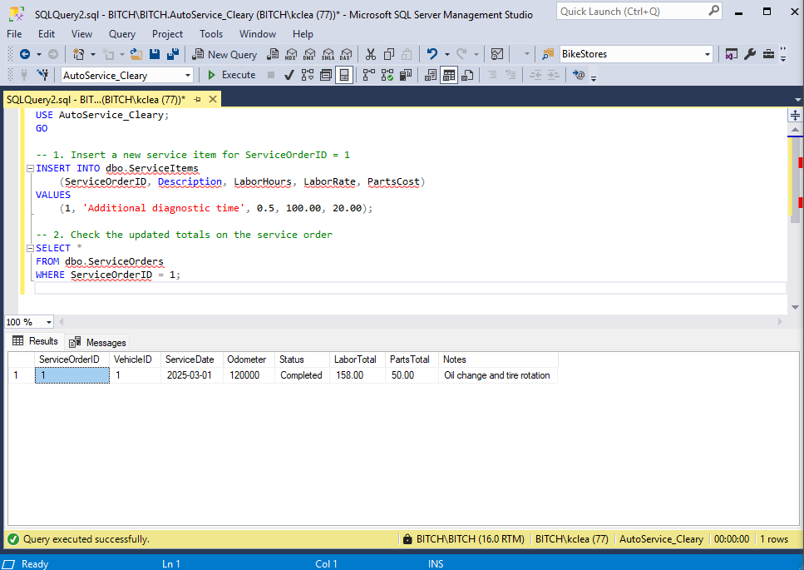
Create a view to support this business process. Save as IT3060FinalProjectTrigger_[YourLastName].sql.

[Insert a screenshot of your code that will test your trigger and display the results. Your server’s name in object explorer and database name should be included in the screenshot.]

Part 4 – Security Plan

- For this final step, you will create a SQL authenticated login for the database. You will demonstrate your ability to create a server login, database user, grant and revoke access to a database object.
